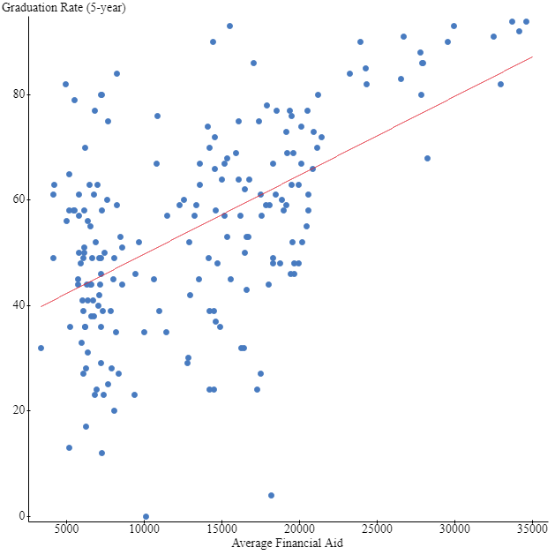

Correlation between Average Financial Aid and Graduation Rate (5-year) is:
0.55193671
EXPLANATION
This is a statistical report that analyzes two quantitative variables (graduation rate and average financial aid) taken from the sample college dataset. The response (dependent) variable is graduation rate while the explanatory (independent) variable is average financial aid. Graduation rate depends on average financial aid. If financial aid is high, graduation rate is also expected to be high. This is due to the assumption that availability of enough finances makes services such as learning to run smoothly and effective hence increasing graduation rate.
Scatterplot
The scatterplot was used to determine whether there is a relationship between graduation rate and the average financial aid. It shows that there is a positive nonlinear relationship between the two variables.
Correlation coefficient
The Correlation coefficient between Average Financial Aid and Graduation Rate (5-year) is:
0.552. This shows that there is a weak positive correlation between graduation rate and average financial aid. The scatterplot does not show a linear trend of the variables. This means that there is a weak liner relationship which is positive. It is positive because the variables are increasing towards the right side as shown on the scatterplot.
The least squares regression line
The equation of the least squares regression line is: Y=34.814+0.0001496X. This regression equation shows the relationship between graduation rate and average financial aid. It shows how a unit change in explanatory variable (average financial aid) affects the response variable (graduation rate). The equation shows that a unit changes in average financial aid increases the graduation rate by 0.0001496 units. The slope in terms of the data is the coefficient of the X in the regression equation =0.0001496. This slope shows by how many units the response variable is affected by a unit change in the explanatory variable. The Y intercept in regression equation is 34.814. it is the value of the response variable when the explanatory variable is equal to zero. It is the value of graduation rate when there is no average financial aid given. This is impossible because in our dataset there is no graduation when average financial aid is not given/=0. Therefore it does not make sense to interpret the Y intercept.
Residue
Residuals are observed in regression analysis. The difference between the observed value of the dependent/ response variable and the predicted value of the dependent/response variable is called a residue.
Residue= observed value-predicted value.
To calculate the residual, we take use the Allegheny college as an example. The value of graduation rate which is our dependent variable for this college is 80.This is the observed value.
We now take a point that lies on the regression line equation. We take the point (21000, 64). The value of the dependent variable is 64.This point is the predicted value. The Residue is 80-64=16. 16 lies below the line of best fit. Therefore the college is below average. This means that it is below the average graduation rate.

